**Business analytics, applied modeling and prediction**

**Coursework**

Student number: 220681535

# 

# Table of contents

**Table of contents 2**

**Summary 3**

**Main part 4**

**Introduction 4**

**Overview 5**

**Client Base Analysis 6**

**Categories Analysis 7**

**Shipping Analysis 9**

**Clients behaviour 11**

# 

# Summary

Number of words (1420)

This business analysis research will show critical insights about our company market performance and operations efficiency. To perform this analysis there was a story of five dashboards built using Tableau software.

In the “Overview” section we have found the following insights: the most profitable regions for our company are North America, Western Europe and China, unprofitable countries are China and Nigeria, profit for other regions distributed practically the same, there are practically no outliers. Half of our clients are Consumers. During the Client Base Analysis, it was found that we have a very loyal customer base all over the world and potential for international growth, but a catastrophically small number of new clients in the last few years. Category analysis showed that the most profitable categories are Copiers and Phones, while Tables are loss one. The most marginal subcategory is Paper for all 3 segments with a margin of 26%. Shipping analysis allowed us to find countries with high shipping costs, one of which was China(one of the countries with highest profit), so it was suggested to deliver products there through bordering Kazakhstan - a country with one of lowest shipping costs. Also in terms of optimization it was suggested to give preference to medium-priority shipping. Finally, analysis of clients behavior showed spending habits among consumers, based on it there was a recommended weekday marketing strategy. Stability in Average Order Value can be used for a marketing strategy based on consistent customer behavior

Together, these dashboards guide strategic decisions to refine customer engagement, optimize product offerings, and streamline shipping logistics, all aimed at expanding market reach and driving growth.

# Main part

# Introduction

In my research, I present a consistent study of our company aimed at finding important insights and hidden inefficiencies. My story consists of 5 dashboards logically connected by researching the work of our company and searching for valuable insights on the main components of the company's profits

The research begins with the dashboard "overview" which provides general information about the functioning of the company, its customers and profitability. Next, we will examine our Сustomer Base for such important indicators as customer retention, growth, mobility and distribution by sales

Next, we will start searching for insights among our product categories and subcategories. Let's define the largest categories of goods, the profitability of subcategories and marginality. We will find unprofitable types of goods and the distribution of sold productsю. The next stage of our story will be the analysis of the supply chain and the delivery of goods. Based on data from previous dashboards, we will find insights and inefficiencies in the area under consideration and suggest ways to eliminate them and drive profits.

In the latest dashboard, we will explore the behavioral habits of our customers, on the basis of which it will be possible to develop marketing strategies and make further plans for the development and functioning of the company.

From the insights received, recommendations will be made to improve each area of our company, which will represent a consistent strategy for improving the company.

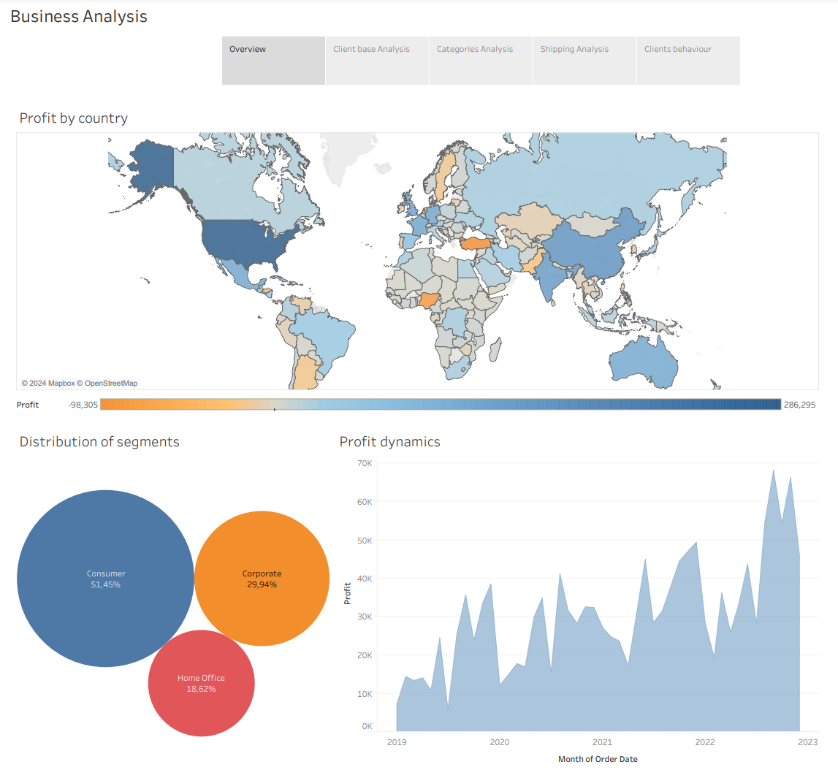

# Overview

The overview dashboard presents a concise and meaningful analysis of our company. A country-by-country profitability survey shows that North America, western Europe and China bring the largest profits. The most unprofitable regions are Turkey and Nigeria, indicating any inefficiencies in these countries.

Based on the analysis of our audience by segment, we can see that the largest part is made up of Consumers who are almost half of all our customers, 30% are Corporate clients and the majority occupy a Home office.

Considering the dynamics of our company's profitability, we can unequivocally state a positive trend, which is very good news. We can also observe seasonality in our data in such a way, the least profitable months are January, April and July, and the most profitable ones are March, June, December. We can explain this seasonality by holidays and quarterly.

Recommendations for senior management include:

* Investigate underperforming regions to adapt marketing strategies and product offerings.
* Capitalize on the strong 'Consumer' segment while developing growth strategies for the 'Home Office' segment.
* Focus investments on the high profit regions and try to adapt strategies of this region to other

# Client Base Analysis

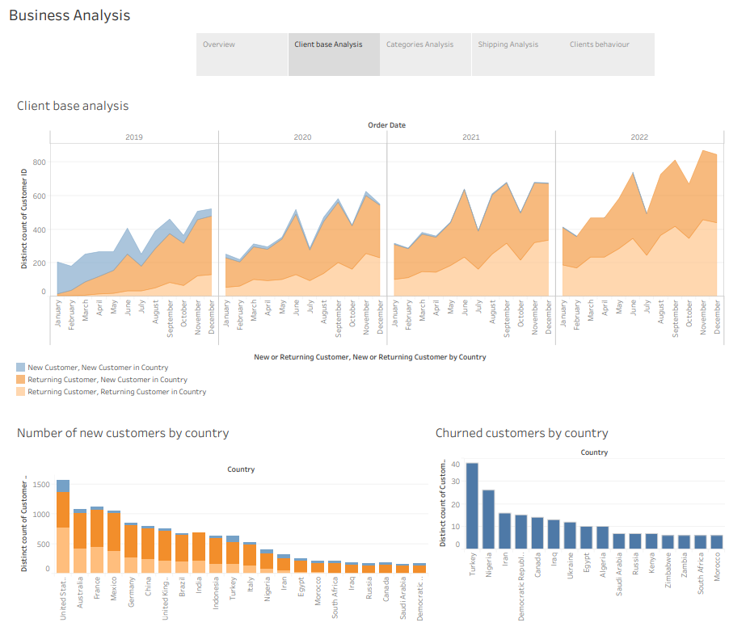

The area plot shows the number of new customers, new customers by country, and the number of returning customers. As we can see, the largest growth in the customer base occurred in 2019, but after that the flow of new customers fell catastrophically, which is a very disturbing insight. However, there is also good news, based on the schedule, we can state a high retention of the audience and its return rate, which is very valuable. The number of orders placed by old customers is growing every year, which indicates high customer loyalty.

Looking at the histogram of the number of new buyers by country, we can see the internationality of our buyers, but most of these buyers come from a certain cluster of countries. This may indicate a high level of customer loyalty, since they even use our services in other countries. However, this also suggests that despite the successful entry into some countries, our company was able to realize only a little of its international potential, or for some other more serious reason

From the customer churn chart, we see that for a total base of 15,000 customers, we have a very high degree of audience retention. Such low indicators indicate that once customers use our products, they remain satisfied and stay with us, which indicates a high level of quality and service and a strong connection between the company and the buyer

Recommendations:

* to use the existing experience of selling goods to undeveloped regions and combine it with a marketing strategy for entering new groups of buyers
* to use existing foreign clients to enter new markets, for example, by introducing referral programs in undeveloped countries
* Develop strategy for attracting new customers

# Categories Analysis

The "Categories Analysis" dashboard provides a detailed breakdown of profitability across various sub-categories and segments. From the waterfall diagram we can accumulate profit by every subcategory of goods. The graph shows that the profit between the subcategories of goods is distributed rather unevenly. Thus, the most profitable subcategories are Copiers and Phones. We also have one unprofitable product category Tablesprofit, indicating losses.

From the treemap, we can see the distribution of sales by each category, their average marginality, as well as the share of each category. Thus, sales were evenly distributed between the three categories, however, Technologies and Office Supplies show a margin of about 13%, while this indicator for Furniture is almost two times less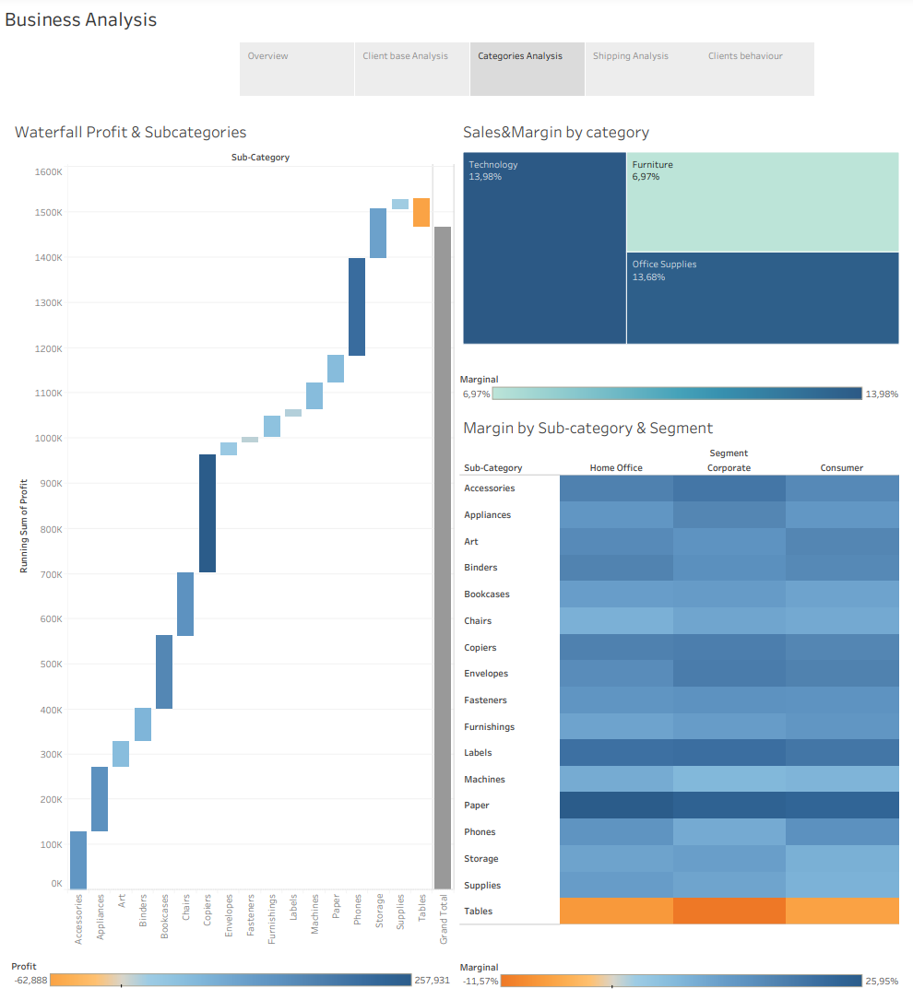

The heat map shows the marginality of each category among each segment. Among all three segments, the absolute margin leader is Paper with a margin of 26%, which is a very high indicator. However, we have a category with a negative margin of 12% - these are tables. The margin between the other subcategories was evenly distributed in the range from 10% to 16%.

Recommendations:

* Focus on promoting high marginal subcategories like Paper.
* Reassess the pricing strategy for the 'Furniture' category to improve margins.
* Investigate the losses in the 'Tables' sub-category.

# Shipping Analysis

On the dashboard, you can see a map showing the average shipping cost by country. Thus, we see that such a highly profitable country as China has extremely high shipping costs, which may be a factor constraining profit growth in this region. We also see a country with an extremely low cost of delivery - Kazakhstan, which in the future may become a logistics hub.

An analysis of the cost of delivery by category shows that the Tables category has the highest value. From the previous dashboard, we remember that this category is the only unprofitable one, so we can talk about the connection between these two factors.

The "Distribution of order by Priority" highlights a preference for medium-priority shipping, as it is optimal in terms of price and quality. Low-class and critical deliveries are the least popular. The low volume of high critical delivery is explained by the low demand for it due to the high price.

Also, during the analysis, I considered the average delivery time by country, but this did not give any insight since the delivery time for all countries is in the range between 3 and 4 days

Recommendations:

* Try to consider Kazakhstan, which has the lowest shipping cost, as a hub for sending goods to China (one of the most profitable countries and the country with the highest shipping cost). This will simultaneously allow us to enter the Central Asian market and increase the attractiveness for customers from China
* Explore other shipping methods for the chairs category, perhaps it can reduce logistics costs and as a result, remove this category from losses
* As part of process optimization, you can try to abandon low-priority delivery and, depending on the results of this experiment, make a decision

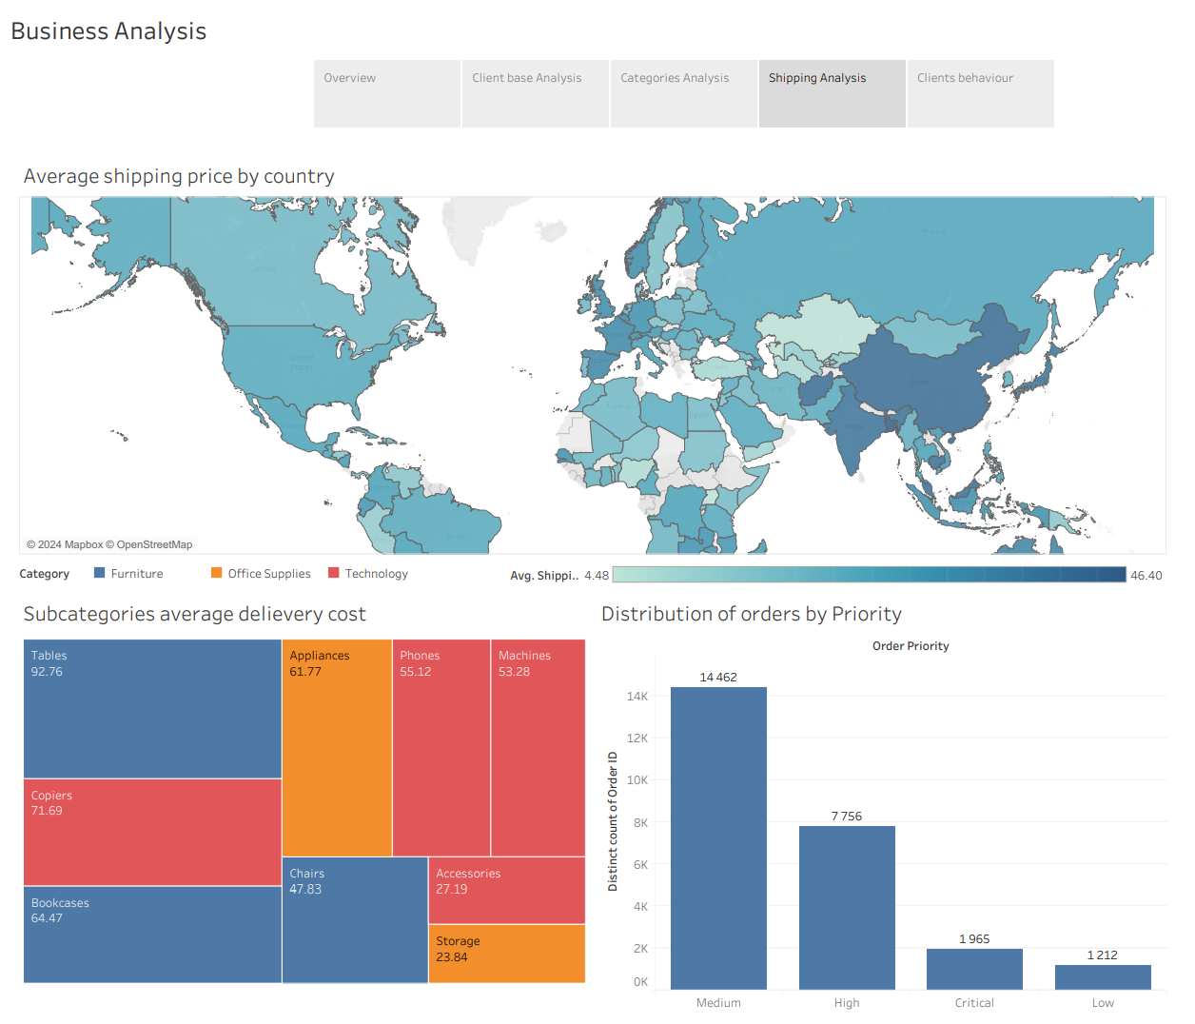

# Clients behaviour

The dashboard reveals key insights into sales distribution, order frequency by weekday, and trends in Average Order Value (AOV).

From the sales distribution chart, we see that low-cost orders have an extremely high frequency, and in the cost range from 950 to 2850, the number of sales tends to zero. It follows that smaller transactions play a decisive role in sales volume

The "Distribution of Orders by Weekdays" pie chart shows a relatively even distribution of orders throughout the week, with Tuesday and Saturday slightly leading. This even spread suggests a consistent demand across the week without significant peaks or troughs.

The "Average Order Value" bar chart shows a stable condition, although it has small fluctuations and seasonality. This suggests that purchasing habits have remained the same over time.

* Develop a strategy to increase sales with high value, for this you can attract customers from a low-selling segment
* Try to make the distribution of sales by day of the week more uniform so that you can reduce the load on the system. To implement this advice, you can try to introduce discounts by day of the week
* Using the current stability of AOW, you can try to develop a strategy to increase this indicator